Project Design Phase-II
Technology Stack (Architecture & Stack)

Date | 20 February 2026
Team ID | LTVIP2026TMIDS47668
Project Name | Rising Waters: A Machine Learning Approach to Flood Prediction
Maximum Marks | 4 Marks

Technical Architecture: Rising Waters
The system architecture for the Rising Waters: Flood Prediction project integrates multi-source data ingestion, temporal deep learning, external meteorological API integration, and a GIS-enabled web application.
Example: Order processing during pandemics for offline mode
Reference: https://developer.ibm.com/patterns/ai-powered-backend-system-for-order-processing-during-pandemics/
Guidelines:
Include all the processes (As an application logic / Technology Block)
Provide infrastructural demarcation (Local / Cloud)
Indicate external interfaces (third party API’s etc.)
Indicate Data Storage components / services
Indicate interface to machine learning models (if applicable)
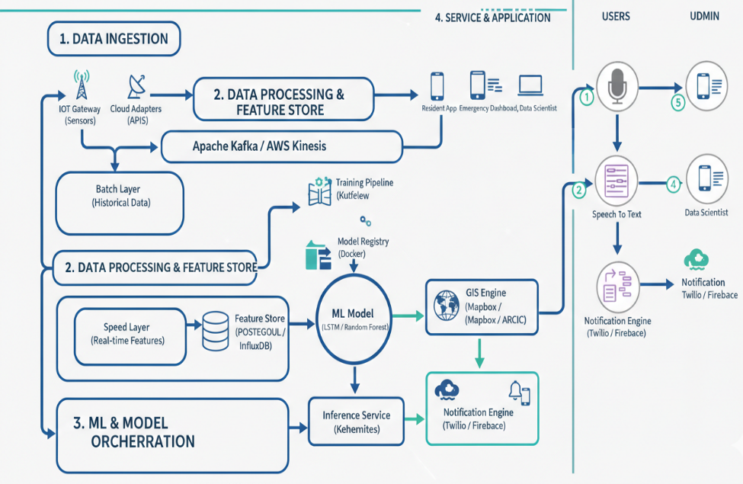

Component | Technical Implementation
Data Ingestion | Fetches historical and real-time hydrological data (water levels, flow rates) and atmospheric data (precipitation, humidity) via USGS and NOAA APIs.
Preprocessing Pipeline | Handles temporal synchronization of sensor data, missing value imputation using linear interpolation, and feature scaling for neural network compatibility.
ML Engine (LSTM) | Utilizes a Long Short-Term Memory (LSTM) recurrent neural network to capture long-term dependencies in rainfall-runoff patterns, allowing for accurate time-series forecasting.
External Integration | Connects to live weather services (e.g., OpenWeather or IBM Weather) to feed future precipitation forecasts into the trained model for proactive "Lead-Time" alerts.
Visualization Layer | A Flask or FastAPI web application that renders interactive hydrographs and Mapbox/Leaflet heatmaps to visualize predicted inundation zones.
Deployment | Containerized using Docker and hosted on cloud platforms (AWS/Azure) to ensure high availability during extreme weather events.

S.No | Characteristics | Description | Technology
1 | Open-Source Frameworks | Deep learning and geospatial frameworks for temporal modeling and mapping. | TensorFlow/PyTorch (LSTM), Pandas, NumPy, Scikit-learn, Geopandas, Leaflet.js
2 | Security Implementations | Protection of sensitive critical infrastructure data and emergency alert integrity. | OAuth 2.0, API Key Encryption (Secrets Manager), HTTPS, Input Sanitization
3 | Scalable Architecture | Event-driven architecture capable of handling data spikes during storms. | FastAPI/Flask + Docker + Kubernetes for auto-scaling during weather events
4 | Availability | Multi-region deployment to ensure the system stays online even if local grids fail. | AWS Route 53, Multi-AZ Load Balancers, Cloudflare for DDoS protection
5 | Performance | Low-latency inference for real-time alerts and efficient handling of large raster/satellite files. | Redis Caching, Model Quantization, WebSockets for real-time data streaming

